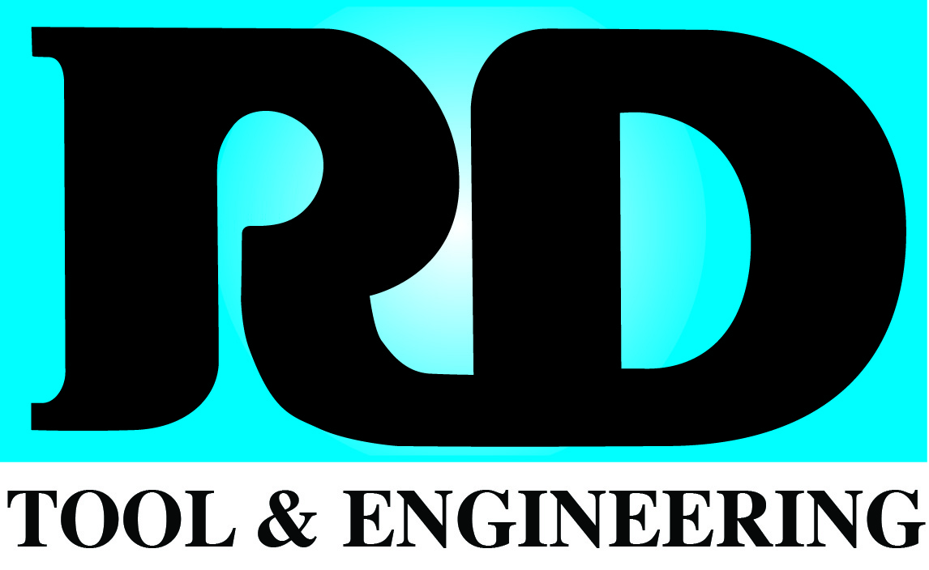

Manufacturer of Injection Molds
2909 State Street, Omaha, NE 68112
402-455-9070 Fax 402-934-5075

Job Title: Toolmaker / CNC Machinist

Job Type: Full-Time

Department: Tool Manufacturing

Summary:

We’re a company that established its presence in the manufacturing world with three simple beliefs: Quality Throughout, Proven Designs, and Excellence in Performance. To keep our growth plans in motion, we seek a self-motivated individual with a strong work-ethic, positive attitude and experience in manufacturing to create injection molds that “bring plastic parts to life”.

Essential Functions/Tasks:

1. Assist in the planning of a tool project/activity.

- Inspect and troubleshoot molds.
- Complete common details on prints that do not alter design.
- Participate in Tool Reviews. Review with manager and foreman project designs, prints, sketches and T.M.O.'s. Also, review overview of design.
- Solicit help from manager or engineer for design theory. Tool room foreman for set-up, procedure, how to's.
- Keep informed of new technology.

2. Execute the plan.

- Run machines as assigned.
- Assemble molds.
- Perform machine and tool room preventive maintenance.
- Know and adhere to all applicable RD Tool & Engineering policies.
- Know and adhere to all applicable RD Tool & Engineering procedures.

3. Document work performed.

- Complete requisitions when inventory needs are identified.
- Complete Mold Maintenance forms.
- Gather all documents into the Job File after project is complete.

4. Miscellaneous.

- Open & secure building.
- Unload trucks.
- Drive forklift.
- Housecleaning on shop floor.

Lifting - 80 pounds maximum of 12 times per day. 100-225 pounds with 2 people.

Qualifications:

Education
- High School Diploma with 2+ years of experience.
OR
- Associate degree in Machine Tool, Cad/Cam Technology, Tool & Die program from Community College or equivalent.

Experience
- 2+ years of manufacturing experience (Preferred).
- CAD/CAM software knowledge (Preferred).

Benefits:

- Health Insurance
- Vision Insurance
- Paid time off
- 401K Plan

